**Software Development Team**

**Team name:** NAVIG8

**Team logo:**

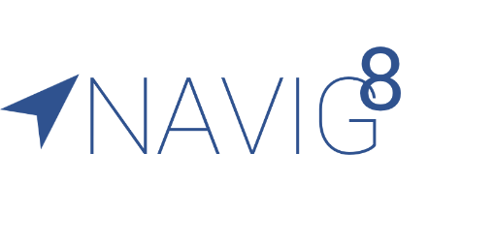

**Team members:**

|  |  |  |
| --- | --- | --- |
| **Name** | **UID** | **Email** |
| Ali, Marvin | 3035361817 | marvin98@connect.hku.hk |
| Chen, Felicia | 3035393614 | felichn@connect.hku.hk |
| Hung, Kevin | 3035343736 | kevhung@connect.hku.hk |
| Lukito, Teresa Gracia | 3035397385 | tlukito@connect.hku.hk |
| Susanto, Deni | 3035361635 | densus@connect.hku.hk |